THE PRESENTATION TITLE (Times New Roman 14)

J. White¹, M. Black^{2,*} (Times New Roman 12)

¹First Affiliation, Mail address, City, Post Code, Country (Times New Roman 12)
²Second Affiliation, Mail address, City, Post Code, Country

* corresponding author: author@ server.edu (Times New Roman 11)

Keywords: keyword 1, keyword 2, keyword 3, keyword 4 (Times New Roman 11)

(Times New Roman 12) The abstract should be written in English on an A4 paper size using the Times New Roman font, size 12 points and single line spacing. The abstract cannot exceed one page length. It should be formatted according to the template provided. The Abstract must be submitted via e-mail to: casuscon@uwr.edu.pl
The names of the authors, written in bold, should be with initials of first names only, followed by the last names in full. Commas should separate the names of the authors. Underline the name of the presenting author and put an asterisk (*) after the name of the corresponding author. Numbers should appear after the author's surname and then before each affiliation. Figures can be inserted into the abstract text only as jpg files of a good quality. Figure captions must be italicized and should be put below figures. References should be consecutively numbered in the text using square brackets and listed by the numbers at the very bottom of the page as regular text (not inserted automatically, as offered by MS Word)
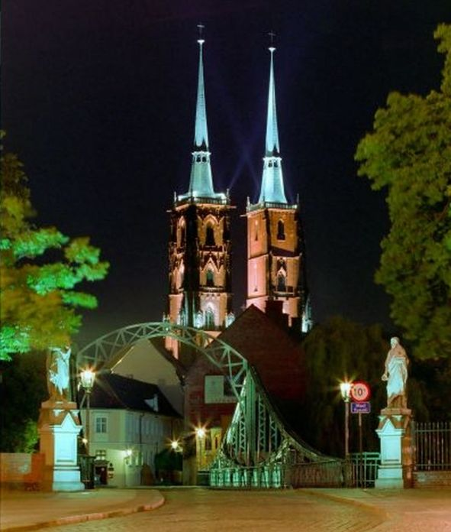
Leave one blank line after the title, list of authors, list of affiliations and abstract text (before References). Leave two blank lines between keywords and abstract text. Do not type "Abstract" at the beginning of the main text. Do not type “References” before their list. Do not insert indentation at the beginning of paragraphs. There should be one blank line above and below an equation.
Abstracts will be printed in the Abstracts Book as submitted without any editing. This is a solely responsibility of the Authors to prepare their abstracts according to this template.
Fig. 1. The night view of Tumski Bridge and the Cathedral towers in the oldest part of Wroclaw.

[1] J. Kowalski, J. Lumin. 150 (2008) 143.

Acknowledgements:

Wrocław on 20……
……………………………………………
……………………………………………
……………………………………………
(names and surnames of the author(s)/
name of the institution, address)

DECLARATION

As the author/co-author/owner* of the work entitled ………………………………………………………………………………………………………………………………………………………………………………………………………………………………………………………………………………………………………………………………………………………………………………………………………………………………………………………………………………………
released in the year …………………, I hereby grant/do not grant* the University of Wrocław a non-exclusive, royalty-free, time unlimited license regarding the following fields of exploitation:

- Entering the work into the computer memory.
- Entering the work into publicly available computer networks.
- Multiplying the work by digital and optical techniques.
- Publishing in the conference book of abstracts.

The author(s) declare(s) that the work is the result of their own production and does not infringe any copyrights and that the copyrights to the work are not limited in the fields covered above.

Licensee’s signature On behalf of all authors
……………………………………… ……………………………………………

*delete the inapplicable

